OIC INTEGRATION FOR GET SUPPLIER INFOR FROM PIM API

Creation Date: December 17, 2020

Last Updated: January 04, 2021

Document Ref: <D>

Version: 1

1. **Title, Subject, Last Updated Date, Reference Number**, **and** **Version** are marked by a Word Bookmark so that they can be easily reproduced in the header and footer of documents. When you change any of these values, be careful not to accidentally delete the bookmark. **You can make bookmarks visible by selecting the Office Button>Word Options>Advanced> and checking the Show bookmarks option in the Show document content region.**

**Approvals:**

|  |  |
| --- | --- |
| <Approver 1> |  |
| <Approver 2> |  |

1. To add additional approval lines, press [Tab] from the last cell in the table above.

oracle.gif

1. You can delete any elements of this cover page that you do not need for your document.

# Document Control

## Change Record

5

| Date | Author | Version | Change Reference |
| --- | --- | --- | --- |
| 2-SEP-20 | Bharathi Yamali |  | No Previous Document |
|  |  |  |  |
|  |  |  |  |
|  |  |  |  |

## Reviewers

| Name | Position |
| --- | --- |
|  |  |
|  |  |
|  |  |
|  |  |

Contents

1 Document Control ii

1.1 Change Record ii

1.2 Reviewers ii

2 Technical Overview 1

2.1 Building Blocks 1

2.2 Block Relationship Diagram 1

3 Connections………………………………………………………………………..2

4. Payload - Design 3

4.1 Request Payloads…………………………………………………………………..3

4.1 Response Payloads……………………………………………………….………..4

5 Interface Design 6

6 Open and Closed Issues 8

6.1 Open Issues 8

6.2 Closed Issues 8

1. To update the table of contents, put the cursor anywhere in the table and press [F9]. To change the number of levels displayed, select the menu option Insert‑>Index and Tables, make sure the Table of Contents tab is active, and change the Number of Levels to a new value.

# Technical Overview

1. The purpose of this task is to assemble all the information that is required to describe the design of a software component into a complete Design Specification. This task is not a substitute for executing the individual design tasks. This specification work product can serve as a structure for completing the design for each component by providing pointers back into the Design Tasks:   
   - DS.040 Develop Design Architecture Description  
   - DS.080 Design Software Components  
   - DS.090 Design Data  
   - DS.100 Design Behavior  
   - DS.130 Design User Interface

This Design Specification documents detailed design for Oracle Get SupplierInfor From PIM API interface.

* This interface is triggered before sales Order creation it get supplier information from PIM API and return to OIC.

## Building Blocks

1. The intent of this section is to list the building blocks that are required to design the designated component. This includes classes, objects, modules, etc. Reference the Module View of the Architecture Description (RD.130) and appropriate Software Component Design (DS.080) to derive the list of classes and their relationships.

Building Blocks

* OCC – Oracle Commerce Cloud
* OFC – Oracle Fusion Cloud
* OIC – Oracle Integration Cloud

## Block Relationship Diagram

1. The intent of this section is to graphically depict how the component under consideration interfaces to related components, external systems, and other actors that interact with the use-case package. Reference the Conceptual View and Module View of the Architecture Description (RD.130) and the class diagram prepared in the Software Component Design (DS.080) and Component Behavior Design (DS.100).

The diagram below represents the base tables of each block or zone of the form (vertical) and tables referenced for validation or lookups (horizontal).

Oracle Integration Cloud

PIM API

Oracle Integration Cloud

# CONNECTION

1. **Connection for trigger**

Adapter Name : REST adapter

Connection : REST_Generic

1. **Connection for GetListItems**

Adapter Name : REST Adapter

Connection : GetInventory_PIM_Server

URL : <http://pim.test.ibmilw.com>

Authentication : Basic Authentication

1. **Connection for GetSupplierBIReport, GetSupplierreport**

Adapter Name : SOAP adapter

Connection : ESSReportConnection

URL : <https://egti-test.fa.us2.oraclecloud.com/xmlpserver/services/ExternalReportWSSService?wsdl>

Authentication : Username Password Token

# ERP BI - Report Design

1. The intent of this section is to document the report format designs for the reports provided by the component. Reference or include the report specification from the User Interface Design (DS.130) for the component.

## REQUEST Payload

**Request Payload for Trigger:**

{

"item" : "abd",

"qty" : 10

}, {

"item" : "bcd",

"qty" : "20"

}, {

"item" : "test",

"qty" : "30"

} ]

**Request Payload for GetListItems**:

{

"Items" : [ {

"item_number" : "7TZ6B",

"quantity" : "95"

}, {

"item_number" : "4FV1M",

"quantity" : "75"

} ]

}

1. The intent of this section is to identify the table, columns, and source values that are required to support the above data elements. Refer to the Physical Database Design (IM.040), to identify the existing tables where the above attributes are located.

## RESPONSE Payload

**Response Payload for Trigger:**

{

"Result" : {

"Supplier" : [ {

"Supplier_number" : "Suppler",

"Supplier" : "Items",

"Supplier_site_code" : "test",

"Item" : "abd",

"quantity" : "10"

}, {

"Supplier_number" : "Suppler",

"Supplier" : "Items",

"Supplier_site_code" : "test",

"Item" : "abd",

"quantity" : "10"

} ],

"status" : "Success .",

"reason" : "error"

}

}

**Response Payload for GetListItems:**

{

"Items" : [ {

"vendor_number" : "10011",

"vendor_name" : "ESSENDANT RECEIVABLES LLC",

"item_number" : "7TZ6B",

"mfr_item" : "102290527",

"quantity" : "25",

"facility_total_on_hand_qty" : "25",

"primary_flag" : "Yes"

}, {

"vendor_number" : "10010",

"vendor_name" : "SP RICHARDS CO",

"item_number" : "7TZ6B",

"mfr_item" : "102290527",

"quantity" : "25",

"facility_total_on_hand_qty" : "25",

"primary_flag" : "No"

}, {

"vendor_number" : "170725",

"vendor_name" : "D & H DISTRIBUTING COMPANY",

"item_number" : "7TZ6B",

"mfr_item" : "102290527",

"quantity" : "45",

"facility_total_on_hand_qty" : "45",

"primary_flag" : "No"

}, {

"vendor_number" : "10010",

"vendor_name" : "SP RICHARDS CO",

"item_number" : "4FV1M",

"mfr_item" : "5151200",

"quantity" : "9",

"facility_total_on_hand_qty" : "9",

"primary_flag" : "No"

}, {

"vendor_number" : "170725",

"vendor_name" : "D & H DISTRIBUTING COMPANY",

"item_number" : "4FV1M",

"mfr_item" : "5151200",

"quantity" : "70",

"facility_total_on_hand_qty" : "70",

"primary_flag" : "No"

} ]

}

1. The intent of this section is to define the design considerations necessary to achieve the data retrieval and storage requirements for performance. Include performance requirements as specified in the Supplemental Requirements (RD.055) for service level requirements (i.e., 1-minute response time, etc.)
2. The intent of this section is to define the implementation strategy for each business rule within this component. Refer to the DS.110 Business Rules Design to capture the Business Rules for this component.

# Interface Design

1. The intent of this section is to design the services between the components and the interfaces with external systems for each Use Case. Refer to DS.080 Software Component Design and focus on calling arguments (i.e., service signature) and logic definition.

**Overview description**: Interface is triggered to get the supplier information from PIM.

**Step1**: Trigger the REST adapter to get Supplier.

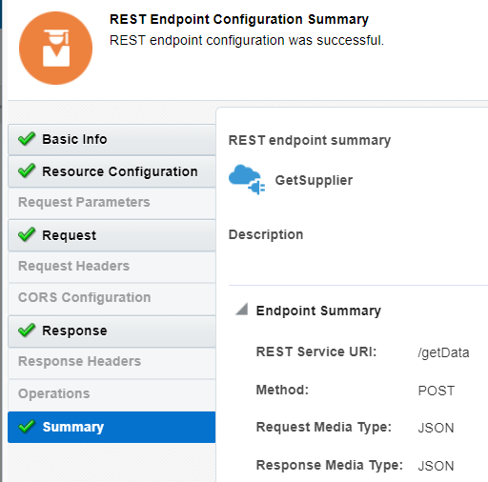

**Step2**: By Using Rest adapter, Get the list of items.

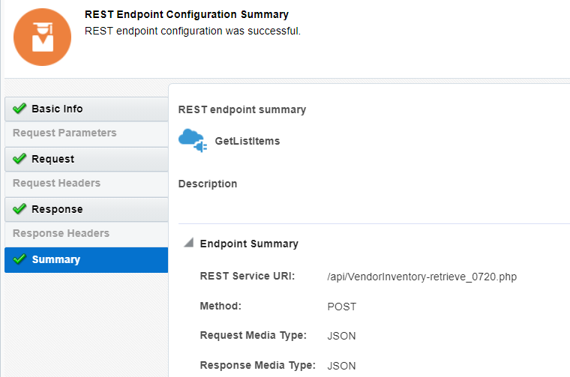

**Step3**: By using Stage file, write the item file from PIM and Read the PIM item file by using the stage file.

**Step4**: Check Item Mismatched, count( vendorrec) > 0.0 then

**Step5:** Get Supplier details by invoke ESSReportConnection SOAP adapter.

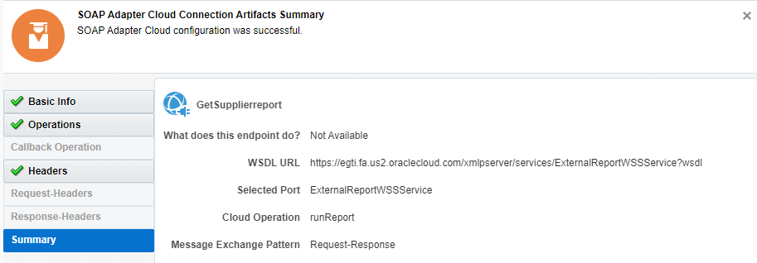

**Step6:** Check report status is No data found,

reportBytes = "U1VQUExJRVJfTlVNQkVSLFNVUFBMSUVSLFZFTkRPUl9TSVRFX0lECg==" then

return to GetSupplier (Parent Integration).

**Step7:** Otherwise, write the query output into the stage file and read the output query by using stage file.

return to GetSupplier (Parent Integration).

**Step8**: Otherwise, For each input item.

* Check if Supplier is "SUPPLY_WA" then go to step6.
* Otherwise, assign K_flag1 is ‘Yes’.
* End for loop.

**Step9:** Assign variables, Invoke ESSReportConnection SOAP adapter to get Supplier details.

**Query**:

select distinct ps.segment1 supplier_number, hp.party_name supplier, pss.vendor_site_id

from poz_suppliers ps, hz_parties hp, poz_supplier_sites_all_m pss

where ps.party_id = hp.party_id and pss.vendor_id = ps.vendor_id and pss.attribute2 = 'YES' and ps.segment1 in (Supplier number).

**Step10**: Check if status is Nodata found or error, reportBytes = "U1VQUExJRVJfTlVNQkVSLFNVUFBMSUVSLFZFTkRPUl9TSVRFX0lECg==" then return main interface.

**Step11**: Otherwise, write the query output into the stage file and read the output query by using stage file.

* For each vendor,
* Check if suppliernumber is SUPPLIER_NUMBER or Supplier is "SUPPLY_WA".
* Otherwise, K_flag is ‘Yes’.
* End for loop.

**Step12**: Return to GetSupplier (Parent Integration).

1. The intent of this section is to document the design changes necessary to provide archiving required to support this component. Refer to the Logical Database Design (DS.150).

# Open and Closed Issues

1. Add open issues that you identify while writing or reviewing this document to the open issues section. As you resolve issues, move them to the closed issues section and keep the issue ID the same. Include an explanation of the resolution.  
     
   When this work product is complete, any open issues should be transferred to the project- or process-level Issue Log (Manage focus area) and managed using a project level Issue Form (Manage focus area). In addition, the open items should remain in the open issues section of this work product, but flagged in the resolution column as being transferred.

## Open Issues

| ID | Issue | Resolution | Responsibility | Target Date | Impact Date |
| --- | --- | --- | --- | --- | --- |
|  |  |  |  |  |  |
|  |  |  |  |  |  |
|  |  |  |  |  |  |
|  |  |  |  |  |  |

## Closed Issues

| ID | Issue | Resolution | Responsibility | Target Date | Impact Date |
| --- | --- | --- | --- | --- | --- |
|  |  |  |  |  |  |
|  |  |  |  |  |  |
|  |  |  |  |  |  |
|  |  |  |  |  |  |